**CODE REVIEW- 2**

Front End of the project using Streamlit python.

All dependencies and libraries:

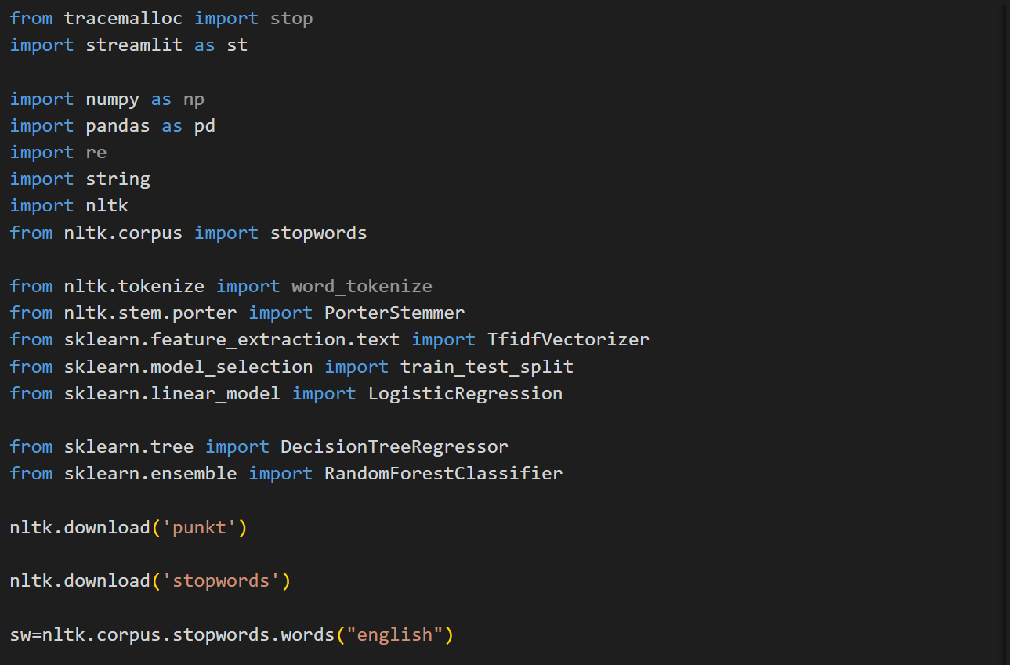

HomePage:

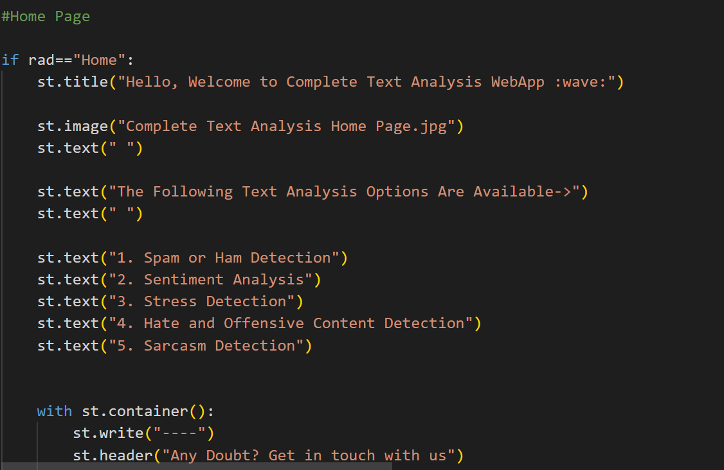

Sentiment analysis webpage:

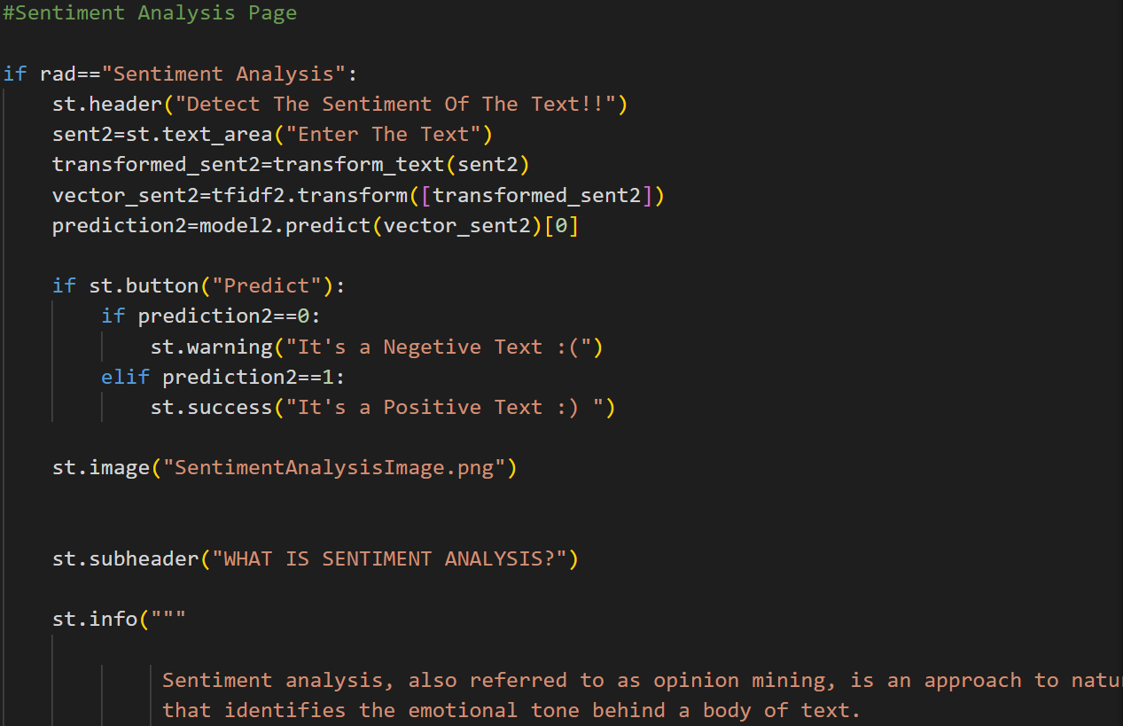

Spam or Ham Analysis WebPage:

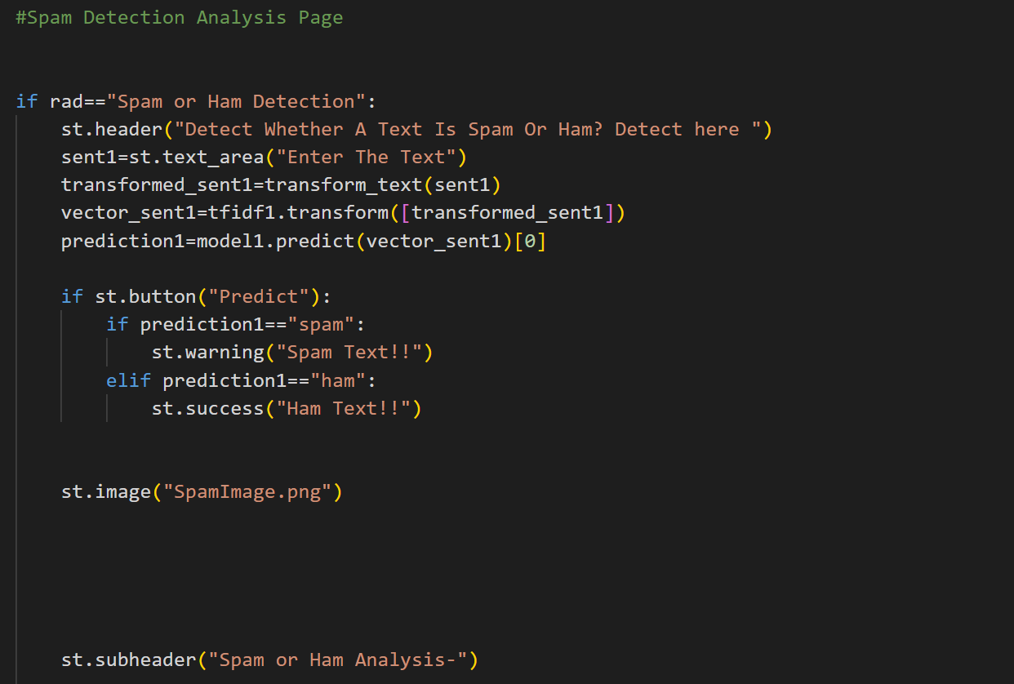

Stress Detection WebPage:

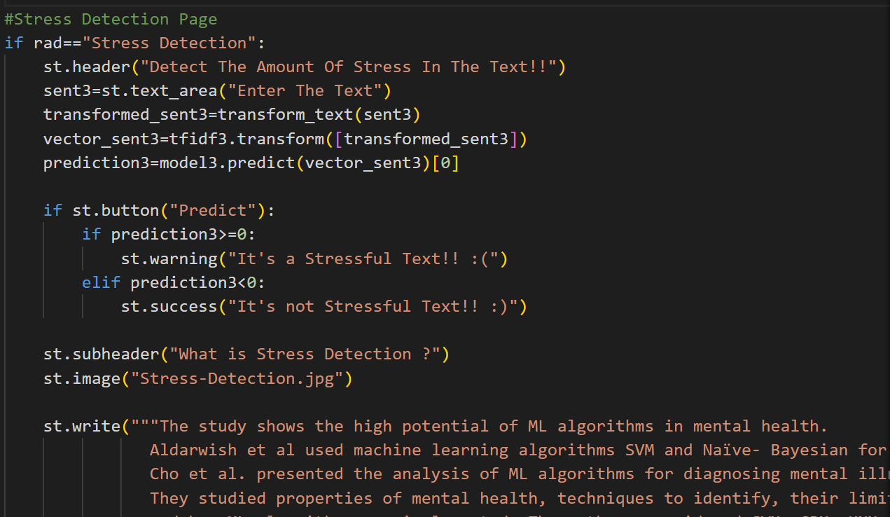

Hate and Offensive Detection WebPage:

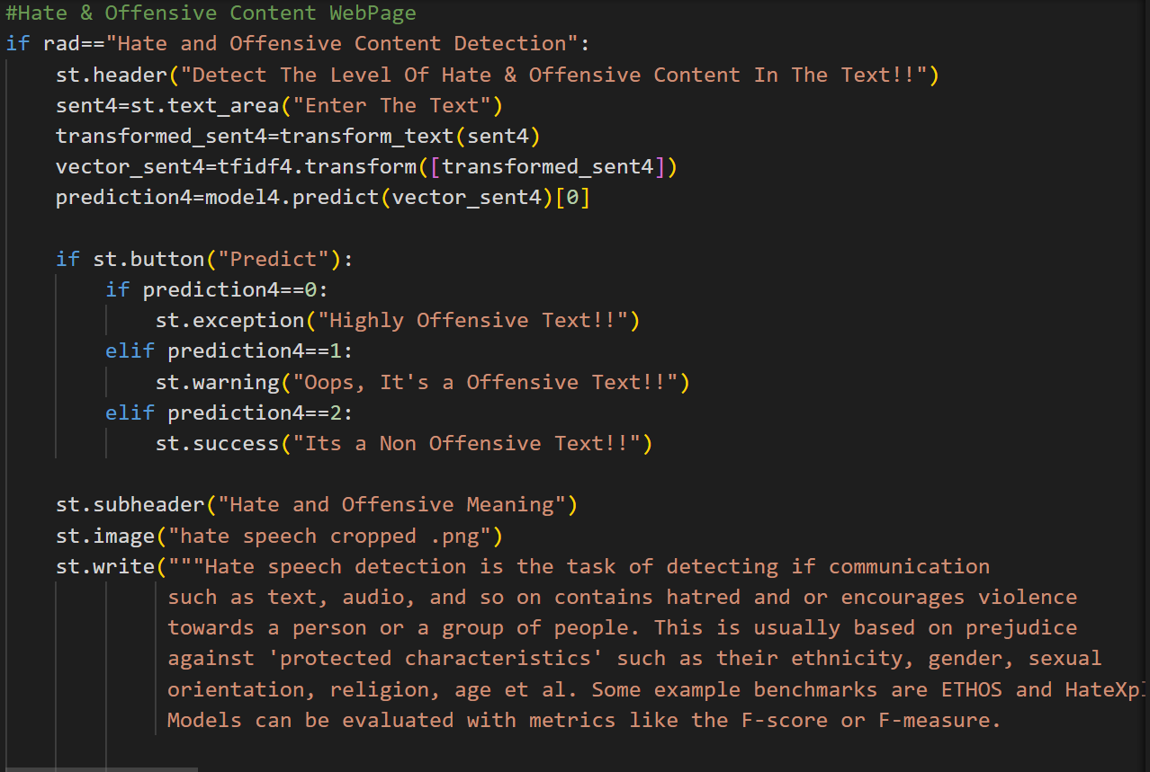

Sarcasm Detection:

